Adiba Binte Amin

B B A M a r k e t i n g ( I U B )

To become a dynamic & versatile person who is capable of merging innovative ideas and getting me into the corporate environment where honesty, creativity, punctuality, and diligence are the cornerstone of success.

# Experience

### 2022 - 2023

#### Independent University (IUB), Bashundhara, Dhaka.



**Library Assistant (LA)**

Library assistants aid librarians in the management and operation of a library. My primary duties include helping customers locate books, checking books in and out at the front desk and shelving books according to my categorization. It is very wonderful job.

### 2021 - 2022

#### Wholesale Express BD Ltd. Uttara, Dhaka.

**Assistant Digital Marketing Officer (Part-Time)**

A digital marketing assistant performs a variety of duties that support the overall goals of a company's sales or marketing departments. In this career, I am responsible for carrying out tasks related to brand development and advertising strategies on digital platforms.

### 2020 - 2023

#### Linear IT Solution, Baridhara, Dhaka.

**Content Writer (Part-Time)**

A Content Writer is typically responsible for researching topics, creating style guides for a company's content, and writing content that helps drive conversions based on the organization's goals. A Website content writer or web content writer is a person who specializes in providing relevant content for websites; it is a sub-specialty of copywriting. Every website has a specific target audience and requires the most relevant content to attract business.

# Reference

## Kazi Aminur Rashid

#### Joint Director State Bank of Bangladesh

**Feroz Alam** Assistant Director of Shonali Bank

**Phone:**

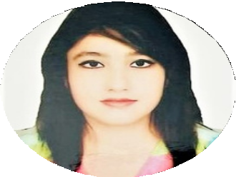

**Contact**

**Phone**

01990427567

**Email**

[1910511@iub.edu.bd](mailto:1910511@iub.edu.bd)

**Address**

23/ kha k.M daslane, Motijheel, Dhaka-1203

**Education**

SSC- 2017

**Motijheel Model High School**

HSC- 2019

**Stamford College, Dhanmondi**

**BBA Marketing (Studied) Independent University (IUB)**

**Expertise**

Photograpy Video Editing Digital Marketing Content Writing Leadership

Verbal & nonverbal Communication

**Language**

**English Bangla Hindi**

**Email :**

01927 550988

[rashidkazi75@gmail.com](mailto:rashidkazi75@gmail.com)

**Phone: Email :**

01706 321822

[ferozalamSB1983@gmail.com](mailto:ferozalamSB1983@gmail.com)